|  |  |  |
| --- | --- | --- |
| Step | Cost of each execution | Total # of times executed |
| 1 | 1 | 1 |
| 2 | 1 | n+1 |
| 3 | 1 | (n2+n)/2 |
| 4 | 1 | (n2 - n)/2 |
| 5 | 1 | 1/6(n3+3n2+2n) |
| 6 | 6 | 1/6(n3-n) |
| 7 | 8 | (n2 - n)/2 |
| 8 | 1 | 1 |

Multiply col.l with col.2, add across rows and simplify T1(n) = 3 + n + (n2+n)/2 + (n2 - n)/2 + 1/6(n3+3n2+2n) + (n3-n) + 4(n2 - n)

= n3+9/2(n2-n)+1/2(n2+n)+1/6(n3+3n2+2n)+3

= 7n3/6 + 11n2/2 – 11n/3 + 3

= **O(n3)**

# Algorithm-2

|  |  |  |
| --- | --- | --- |
| Step | Cost of each execution | Total # of times executed |
| 1 | 1 | 1 |
| 2 | 1 | n+1 |
| 3 | 1 | n |
| 4 | 1 | $\sum_{i=1}^{n}{(n-i}+1)$ |
| 5 | 6 | $\sum_{i=1}^{n}{(n-i})$ |
| 6 | 5 | $\sum_{i=1}^{n}{(n-i)}$ |
| 7 | 1 | 1 |

Multiply col.1 with col.2, add across rows and simplify

T2( n) = 1 + 1 + n + (n+1) + $\sum_{i=1}^{n}{(n-i}+1)$ + $6\sum_{i=1}^{n}{(n-i})$ + $5\sum_{i=1}^{n}{(n-i})$

= 3+2n+ $\frac{n^{2}+n}{2}$ + 11 $\frac{n^{2}-n}{2}$

= n(6n – 3) + 3

= -3n+3

= **O(n2)**

# Algorithm-3

|  |  |  |
| --- | --- | --- |
| Step Cost of each execution | | Total# of times executed in any single recursive call |
|  |  |
| 1 | 4 | 1 |
| 2 | 10 | 1 |
| Steps executed when the input is a base case: **2 steps** | | |
| First recurrence relation: T(n=l or n=0) = **O(1)** = 23 | | |
| 3 | 5 | 1 |
| 4 | 2 | 1 |
| 5 | 1 | (n/2)+1 |
| 6 | 6 | n/2 |
| 7 | 8 | n/2 |
| 8 | 2 | 1 |
| 9 | 1 | (n/2)+1 |
| 10 | 6 | n/2 |
| 11 | 8 | n/2 |
| 12 | 4 | 1 |
| 13 | T(n/2) | 1 |
| 14 | T(n/2) | 1 |
| 15 | 8 | 1 |
| Steps executed when input is NOT a base case: **15** | | |
| Second recurrence relation: T(n>1) =  **2T(n/2) + 15n + 23** | | |
| Simplified second recurrence relation (ignore the constant term): **T(n>1) = 2T(n/2) + O(n)** | | |

Solve the two recurrence relations using any method (recommended method is the Recursion Tree). Show your work below:

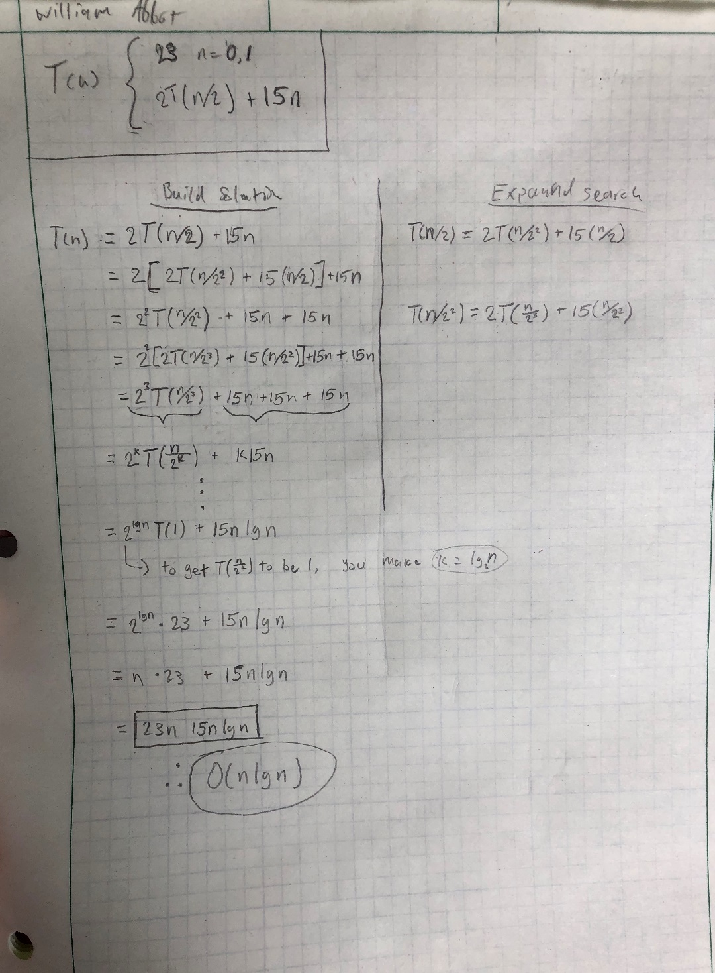

T3(n) = 23n + (15n*log2 n)

= **O()**

|  |  |  |
| --- | --- | --- |
| Step | Cost of each execution | Total # of times executed |
| I | 1 | 1 |
| 2 | 1 | 1 |
| 3 | 1 | n+1 |
| 4 | 11 | n |
| 5 | 8 | n |
| 6 | 1 | 1 |

Multiply col.1 with col.2, add across rows and simplify T4(n) = 1+1+n+1+n+n+1

= 20n + 4

= **O(n)**

Conclusions:



